
Sukkur IBA University
Department of Computer Science
Compiler Construction Lab

Lab # 02: Regular Expressions, Lexical Analysis, and Input Validation in C
Instructor: Muhammad Ismail Qureshi
Submission Profile
Name: Submission date (dd/mm/yy):
Marks obtained: Receiving authority name and signature:
Comments:
________________________________________________________________________________
Instructor Signature

Note: Submit this lab hand-out on LMS/e-learning before the next lab with attached solved activities and exercises

Lab Learning Objectives:
Upon successful completion of this experiment, the student will be able to:
- Understand the role of the Lexical Analyzer (Scanner) in tokenizing raw source streams.
- Formulate Formal Regular Expressions (RE) for C tokens: Identifiers, Keywords, Constants, and Operators.
- Implement procedural regex matching logic in standard C using deterministic finite state logic.
- Utilize POSIX Regular Expression APIs (<regex.h>) in C to validate and extract input strings.

Lab Hardware and Software Required:
• GCC Compiler (MinGW-w64 for Windows, native GCC on Linux/macOS)
• Visual Studio Code / C IDE
• Terminal / Command Line Interface
• PC
Background Theory:

1. Introduction to Lexical Analysis
Lexical Analysis is the first phase of a compiler. Its primary job is to read an input stream of characters from source code, group them into meaningful character sequences called lexemes, and produce corresponding tokens for the parser
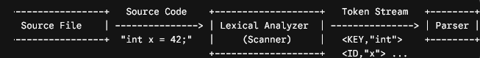
• Lexeme: The actual string of raw source characters matching a pattern (e.g., total_sum, 45.6, ==).
• Token: A tuple consisting of a (Token Category, Attribute Value) (e.g., <IDENTIFIER, "total_sum">).
• Pattern: The rule describing how a token is formed, typically expressed using Regular Expressions.
2. Formal Token Specifications via Regular Expressions
Token Type | Formal Specification (Regex) | Examples
Identifier | [a-zA-Z_][a-zA-Z0-0_]* | count, _temp, val1
Integer Constant | [0-9]+ | 0, 42, 999
Float Constant | [0-9]+\.[0-9]+ | 3.14, 0.001
Relational Operators | == | != | <= | >= | < | > | ==, <=, >
Keywords | if | else | while | int | return | if, int

Lab Examples:

Example 1: Validating Identifiers via Standard C State Logic
Without third-party libraries, lexical pattern matching can be represented using character-by-character validation:
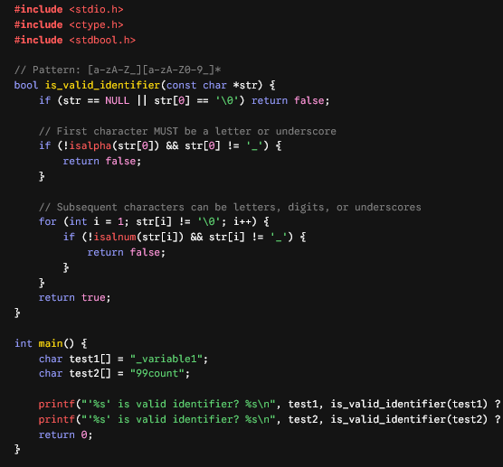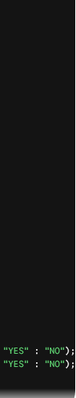

Lcsva,
ab Activities:

Activity 1: Setting Up POSIX Regular Expressions (<regex.h>)
POSIX regex standard is built into POSIX systems (Linux/macOS) and available in MinGW GCC (Windows).
\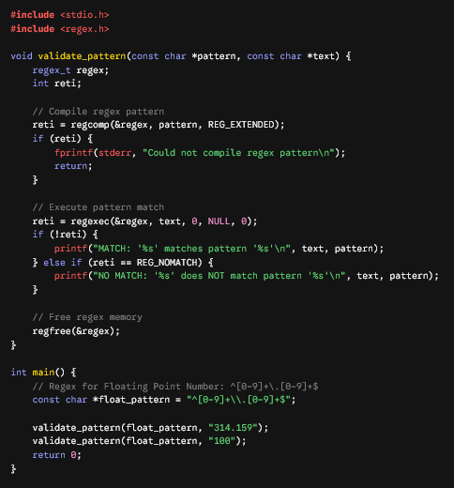
Lab Exercises:

Exercise 1: Keyword vs. Identifier Resolver
Write a C program that reads an input string and checks if it matches an identifier pattern.
- If it matches the identifier pattern [a-zA-Z_][a-zA-Z0-9_]*, check if it belongs to a reserved C keyword list (int, float, if, else, while, return).
- Output whether the string is a KEYWORD, a VALID IDENTIFIER, or an INVALID TOKEN.

Exercise 2: Operator Regex Validator
Using <regex.h> or procedural parsing in C, write a validator that checks whether an input string is a valid C Arithmetic or Relational Operator:
- Arithmetic Operators: +, -, *, /, %
- Relational Operators: ==, !=, <, >, <=, >=

Exercise 3: Full Lexeme Categorizer_
Write a C program that accepts an un-spaced input string containing a constant, identifier, or string literal (e.g., "12.45", "_varName", "\"Hello Compiler\""). The program must run checks against patterns and print out the correct classification token:
- NUMBER_INT
- NUMBER_FLOAT
- IDENTIFIER
- STRING_LITERAL
- UNKNOWN_TOKEN

